The client server relationship

Client and server interaction

Every day, we use the services available over networks and the internet to communicate with other and to perform routine tasks.

We rarely think of the servers, clients, and networking devices that are necessary in order for us to receive an email, update our status on social media, or shop for the best bargains in an online store.

**Most of the commonly used internet applications rely on complicated interactions between various servers and clients**.

**The term server refers to a host running a software application that provides info or services to other hosts that are connected to the network.**

A well-known example of an application is a web server.

There are millions of servers connected to the internet, providing services such as web sites, email, financial transactions, music downloads, etc.

A crucial factor to enable these complex interactions to function is that they use agreed upon standards and protocols.

**Common types of sever software:**

Email

Runs email server software. Clients use mail client software to access email on the server

Web

Runs web server software. Clients use browser software, to access web pages on the server

File

Sores corporate and user files in a central location

The client devices access these with client software

Web server and client IP interactions video

.

URI, URN and URL

**Web resources and web services** such as RESTful APls **are identified using a uniform resource identifier (URI).**

URI is a string of characters that identifies a specific network resource.

It has 2 specializations:

- uniform resource name (URL)

**This identifies only the namespace of the resource** (web pg, img, document…) without reference to the protocol

- uniform resource locator (URL)

This **defines the network location of a specific resource on the network.**

HTTP or HTTPS URLs are typically used web browsers.

These are the parts of a URI:

- protocol/scheme - **HTTPS or other protocols such as FTP, SFTP, mailo, NNTP**

- hostname - www.example.com

- path and file name - /author/book.html

- fragment - #page155

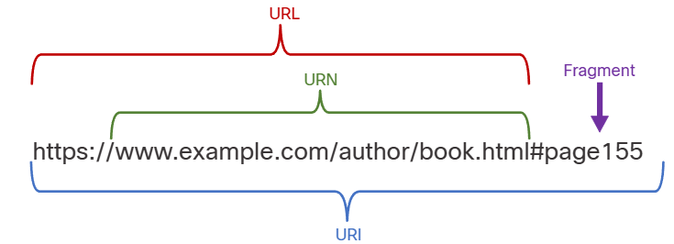

Web traffic in packet tracer video

.